**\*before running the program enter the db credentials for setting up the environment, and for accessing database in both scripts.**

**Behtar Campus Technical Assessment**

Technology used: Python 3.9

**Unit test case:**

a=1

will take inputs for oid, item, ETA

a=2

will take inputs for oid, x

update it to same i.e ‘1 for Netbanking’ ‘2 for wallet’, ‘3 for Cash on Delivery’, ‘4 for Payment failed ‘ by merchant

a=3

will take input for oid

print tracking status of item as shown:

**For db script please execute other python named: database_formation**

**After successful compilation it should look like this:**

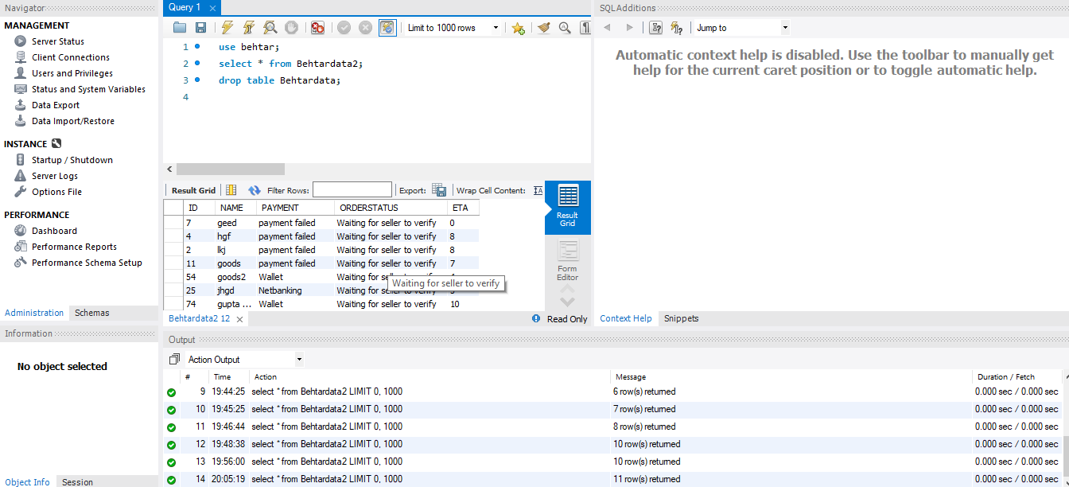

**Executing :**

executing the program is simple . You have to first execute data set program for the formation of pre-requisites. After that the program will ask inputs different stages you can successfully insert update or track from the program itself.

**Flow Chart Diagram**

Create Database

A= 1,2,3

else

1

Exit()

Return to status()

Another Order?

Wrong choice

Try again

Update tracking status using oid

Customer can also track their orders using oid

New Order; Enter value for oid, item and eta

3

2